Christopher Dent

000849456

Lab 1

All parts of the lab are working as intended

3 Things I learned

* How to alter the seeding code to seed the database with Users and Roles
* How to allow users to access views based on role
* How to apply different attributes as a first line of defence to malicious users

3 Things I Could Work On

* How to create and add code to the seeding file to add more than Just Users and Roles (other entities)
* How to not stare at my screen wondering why localhost:7039/Employer isn’t working and giving me a 404 when I named the controller “EmployerS” with an S...
* Learn if there is more attributes I can apply to views and models to further protect against malicious users.

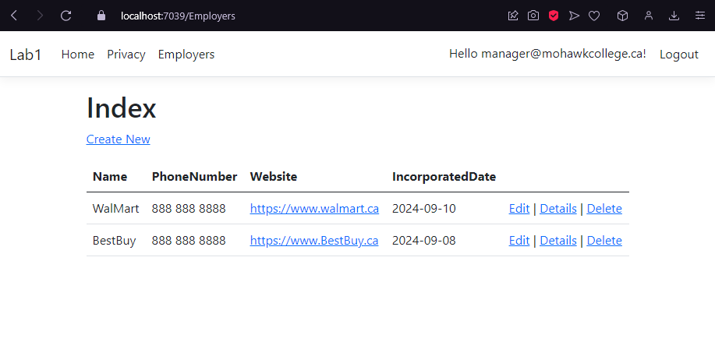Figure 1: Index Logged in as Manager

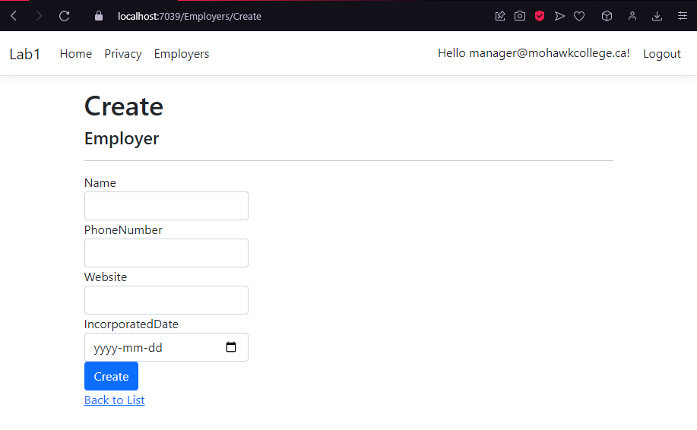Figure 2: Create Logged in as Manager

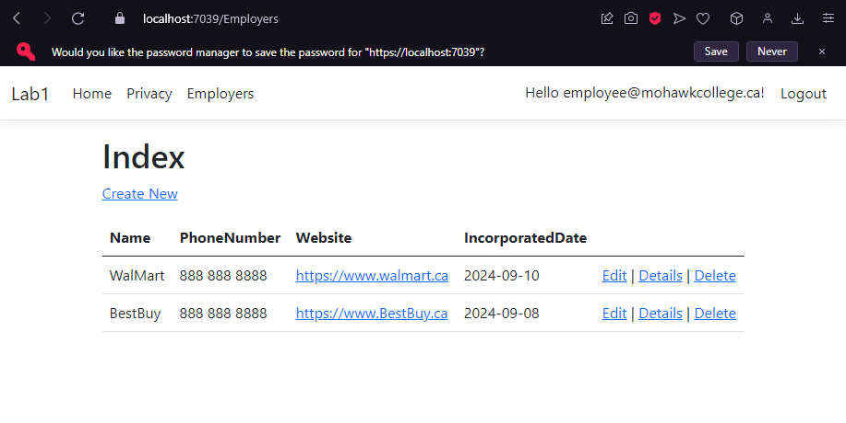Figure 3: Index Logged in as Employee

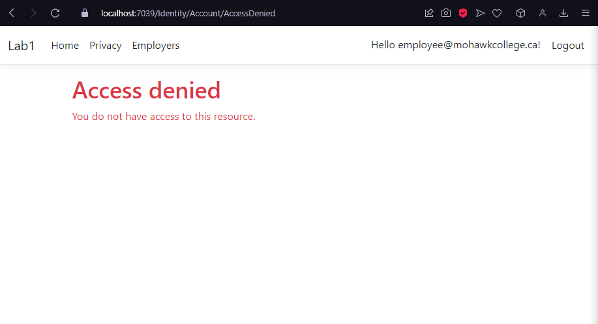Figure 4: Create Logged in as Employee

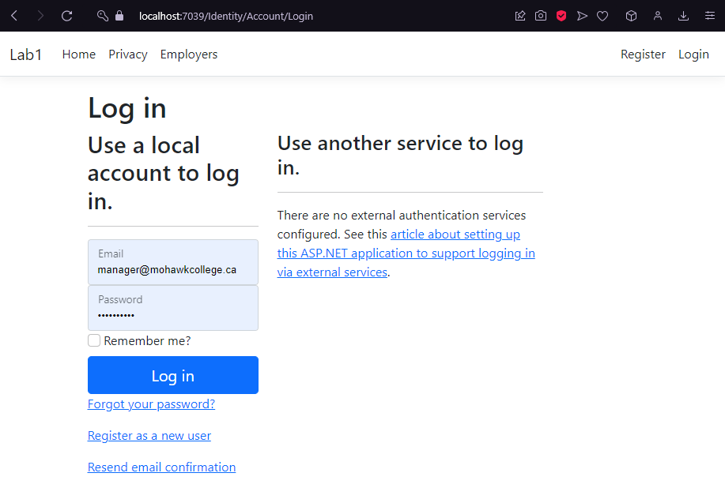Figure 5: Index NOT Logged in